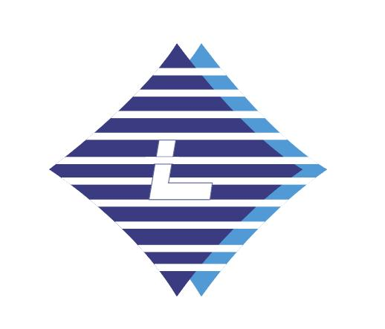

Sailboat is a symbol of the sea and freedom.

Europeans explore all the unknown oceans in the world by sailing ships from the 15th to the 17th century.They opened the era of great navigation when explored new routes and developed overseas trade.

Blcokchain can also be seen as a new great navigation era,which is the next great technological revolution after the industrial revolution and the computer technology revolutio as information technology innovation.

We believe that  [libertyswap3](https://github.com/libertyswap3/lips) will left a strong ink stroke in this era of great navigation,so that the LOGO is designed with sails as the element, which means the spirit of freedom and exploration.